AP Biology vMIT

September 15, 2013

Class 1: Chemistry Review, The Importance of Water

Chemistry Review

**Definitions**

*Matter*: anything that takes up space and has mass.

Matter is made of elements. An *element* cannot be broken down to other substances by chemical reactions.

*Compound*: consists of two or more different elements in a fixed ratio, has characteristics different from those of its elements, e.g. NaCl.

**Essential elements of life**

|  |  |
| --- | --- |
| Element | % of living matter |
| C, O, H, N | 96 |
| P, S, Ca, K, a few other elements | 4 |

*Trace elements* are required by an organism in minute quantities, e.g. iodine.

What happens when you don’t get enough iodine? Goiter.

*Atom:* the smallest unit of matter that still retains the properties of an element.

|  |  |  |  |
| --- | --- | --- | --- |
|  | Proton | Neutron | Electron |
| Charge | + | Neutral | - |
| Mass | 1 Da or 1 amu | 1 Da or 1 amu | negligible |
| Location | Nucleus | Nucleus | Cloud around nucleus |

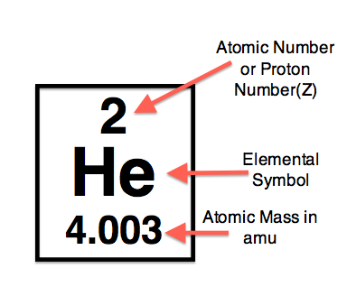

All atoms of an element have the same number of protons.

*Isotope:* forms of an element that contain different number of neutrons, e.g. 12C, 13C, 14C.

A radioactive isotope’s nucleus decays, giving off particles and energy.

fossil dating

medicine-tracers to follow atoms through metabolism (PET scan)

scientific research-Southern blots

**Energy levels of electrons**



Stepwise changes in *potential energy*

When energy is absorbed, the electron is excited and moves to a higher energy level (shell). When energy is lost, the electron falls to a lower energy level.

**Periodic table**

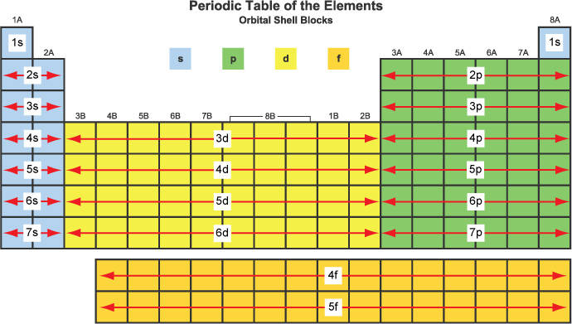

Electrons are held in shells.

The first shell can hold two electrons. All of the other shells can hold eight.

*Valence electrons* are the electrons in the outermost (valence) shell.

Atoms with the same number of electrons in their valence shells have similar chemical behavior. e.g. F and Cl both have 7 valence electrons. They both couple with Na to form NaF and NaCl.

Elements in group 8 have full valence shells. They are *inert.*

The 3D space where an electron is found around 90% of the time is called an *orbital*.

|  |  |  |
| --- | --- | --- |
| Sublevel | # of electrons in each sublevel | # of orbitals |
| S | 2 | 1 |
| P | 6 | 3 |
| D | 10 | 5 |
| F | 14 | 7 |
| G | 18 | 9 |

*Aufbau Principle:* electrons fill orbitals starting at the lowest available energy state before filling higher states (1s before 2s)

*Pauli exclusion principle:* an orbital can hold two electrons max. If there are two electrons in the orbital, they must have opposite (paired) spins.

*Hund’s rule:* When filling sublevels other than s, electrons are paired in individual orbitals before they’re paired up.

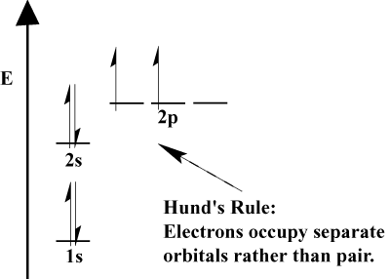

The reactivity of atoms arises from the presence of unpaired electrons in the valence shells.

**Bonding between atoms**

*electronegativity*: attraction for electrons of a covalent bond

Strong chemical bonds

*Ionic bonds*: two atoms are unequal in their attraction for valence electrons, the more electronegative atom strips an electron completely away from its partner, e.g. Na+Cl-

*Covalent bonds*: the sharing of a pair of valence electrons by two atoms

e.g. H2 molecular formula, H-H structural formula

Single bond: share one pair of valence electrons

Double bond: share two pairs of valence electrons

Polar covalent bond: two atoms are unequally shared, H2O

Nonpolar covalent bond: two atoms are equally shared, O2

Valence, or bonding capacity, is the number of covalent bonds an atom can form.

Valence of hydrogen is 1; oxygen, 2; nitrogen, 3; and carbon, 4.

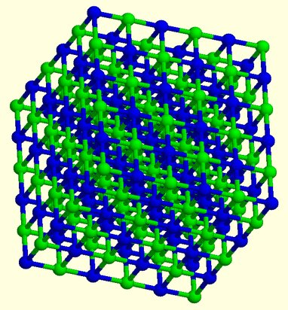

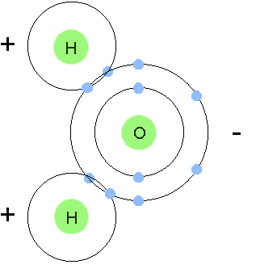

Weak chemical bonds

Hydrogen bonds: hydrogen atom covalently bonded to one electronegative atom is attracted to another electronegative atom, e.g. H2O

Van der Waals bonds: weak bonds as a result of positively and negatively charged regions in a molecule, e.g. Gecko



Weak chemical bonds help proteins fold properly (quaternary structure of proteins).

Molecular shape is crucial because it determines how biological molecules recognize and respond to one another with specificity.

Morphine mimics endorphins by binding to endorphin receptors in the brain.

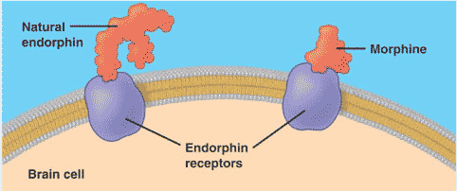

*Reactants* (left side of arrow) and *products* (right side of arrow)

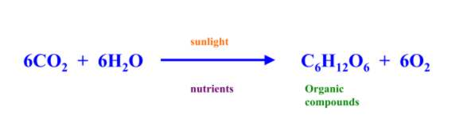

*Equilibrium*: when forward and reverse reactions occur at the same rate.

The Importance of Water

**Water is polar**



The oxygen has a partial negative charge. The hydrogens have partial positive charges.

Hydrogen bonds hold water molecules together.

**Properties of water**

*Cohesion*

*Moderation of temperature*

*Expansion upon freezing*

*Versatile solvent*

Cohesion

Hydrogen bonds hold water together. Bonds are forming, breaking, and reforming frequently.

Allows for water transport against gravity in plants.

Surface tension: how difficult it is to stretch or break the surface of a liquid. Water has a greater surface tension than most other liquids.

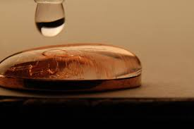

Moderation of temperature

Water absorbs heat from air that is warmer.

Hydrogen bonding gives water a high specific heat (1 cal/g/°C).

*Specific heat*: the amount of heat that must be absorbed for 1 g of a substance to change its temperature by 1° C.

Heat is absorbed when hydrogen bonds break and is released when they form. Water minimizes temperature fluctuations that permit life.

*Evaporative cooling* is based on water’s high *heat of vaporization* (amount of heat a liquid must absorb for 1 g of it to be converted from the liquid to the gaseous state).

Water molecules have a relatively high kinetic energy to break hydrogen bonds. The evaporative loss of these energetic water molecules cools the surface.

Expansion upon freezing

At temperatures above 4° C, water expands as it warms and contracts as it cools.

At temperatures below 4° C, water expands. When water freezes, more organized hydrogen bonding causes expansion into a crystalline lattice.

Ice is less dense than liquid.

Ice allows life to exist under frozen surfaces of lakes and polar seas.

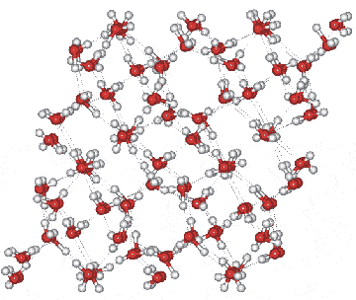

Versatile solvent

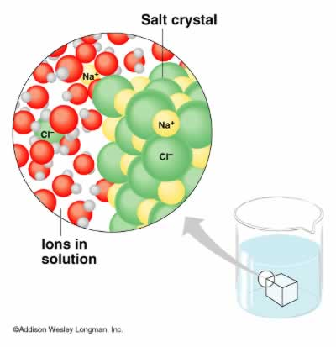

Polar molecules mix well with other polar molecules. Water dissolves ions and polar substances.

An *aqueous* solution is one in which water is the solvent.

A *hydration shell* forms around NaCl when NaCl is dissolved in water.

*Hydrophilic* substances have an affinity for water. *Hydrophobic* substances do not.

*Colloid*: a stable suspension of fine particles in a liquid.

*Solvent*: dissolving agent of a solution, e.g. water

*Solute*: substance that is dissolved

*Molarity*=number of moles of solute/liter of solution.

*Mole*=number of molecules of a substance.